

**Project Title**

**Measuring the Pulse of Prosperity: An Index of Economic Freedom Analysis**

**Team ID :** LTVIP2025TMID60963

**Team Members:**

* BHANU ENUGU

* BHAVANA TIRUMANI

* BHAVYA KAVURU

* BINDUSRI GOPISETTI

# • INTRODUCTION

## 1. Project Overview

Economic freedom is the fundamental right of every human to control his or her own labor and property. In an economically free society, individuals are free to work, produce, consume, and invest in any way they please. In economically free societies, governments allow labor, capital, and goods to move freely, and refrain from coercion or constraint of liberty beyond the extent necessary to protect and maintain liberty itself.

## 2. Purpose

The purpose of this project is to explore For much of human history, most individuals have lacked economic freedom and opportunity, condemning them to poverty and deprivation.

# • IDEATION PHASE

## 1. Problem Statement

Today, we live in the most prosperous time in human history. Poverty, sicknesses, and ignorance are receding throughout the world, due in large part to the advance of economic freedom. In 2022, the principles of economic freedom that have fueled this monumental progress are once again measured in the Index of Economic Freedom, an annual guide published by The Heritage Foundation, Washington's No. 1 think tank.

Empathy Map Canvas

We measure economic freedom based on 12 quantitative and qualitative factors, grouped into four broad categories, or pillars, of economic freedom:

## 2. Brainstorming

* Rule of law (property rights, government integrity, judicial effectiveness)
* Government size (government spending, tax burden, fiscal health)
* Regulatory efficiency (business freedom, labor freedom, monetary freedom)
* Open markets (trade freedom, investment freedom, financial freedom)
* Compare regions and identify best-performing countries
* Develop an interactive dashboard for easy data exploration

# • REǪUIREMENT ANALYSIS

## 1. Customer Journey Map

**Discovery:** Users learn about the Index of Economic Freedom

**Exploration:** Access interactive dashboards and visualizations **Insights:** Analyze country rankings and economic trends

**Action:** Use insights for research, policy-making, or awareness

## 2. Solution Requirement

**Functional Requirements:**

* Data collection and preprocessing
* Tableau dashboard development
* Web application integration
* Interactive visualizations based on economic indicators

**Non-Functional Requirements:**

* User-friendly interface
* Real-time accessibility via Tableau Public
* Responsive design for mobile and desktop

3. Data Flow Diagram

Data Sources → Data Cleaning → Tableau Visualizations → Web Integration → End Users

## 4. Technology Stack

* **Data Processing:** Python, Pandas

* **Visualization:** Tableau, Tableau Public

* **Web Application:** HTML, CSS, Bootstrap

# • PROJECT DESIGN

## 1. Problem Solution Fit

The project provides a visual, data-driven approach to understanding how economic freedom contributes to prosperity, enabling users to analyze global trends effectively.

## 2. Proposed Solution

An interactive platform that presents country rankings, economic indicators, and their relationships through dynamic dashboards and storyboards.

## 3. Solution Architecture

* Data collection from reliable global sources

* Data cleaning and preparation

* Development of Tableau dashboards

* Integration with a responsive web application

# • PROJECT PLANNING G SCHEDULING

## 1. Project Planning

Phase Timeline

Requirement Gathering Week 1

Data Collection C Preprocessing Week 2

Data Analysis C Visualization Week 3-4

Dashboard C Story Development Week 5

Web Integration C Testing Week 6

Final Report C Presentation Week 7

# • FUNCTIONAL AND PERFORMANCE TESTING

## 1. Performance Testing

* Tested dashboard load times and responsiveness

* Verified accurate data rendering across devices

* Ensured stable integration between Tableau Public and the web application

# • RESULTS

1. Output Screenshots

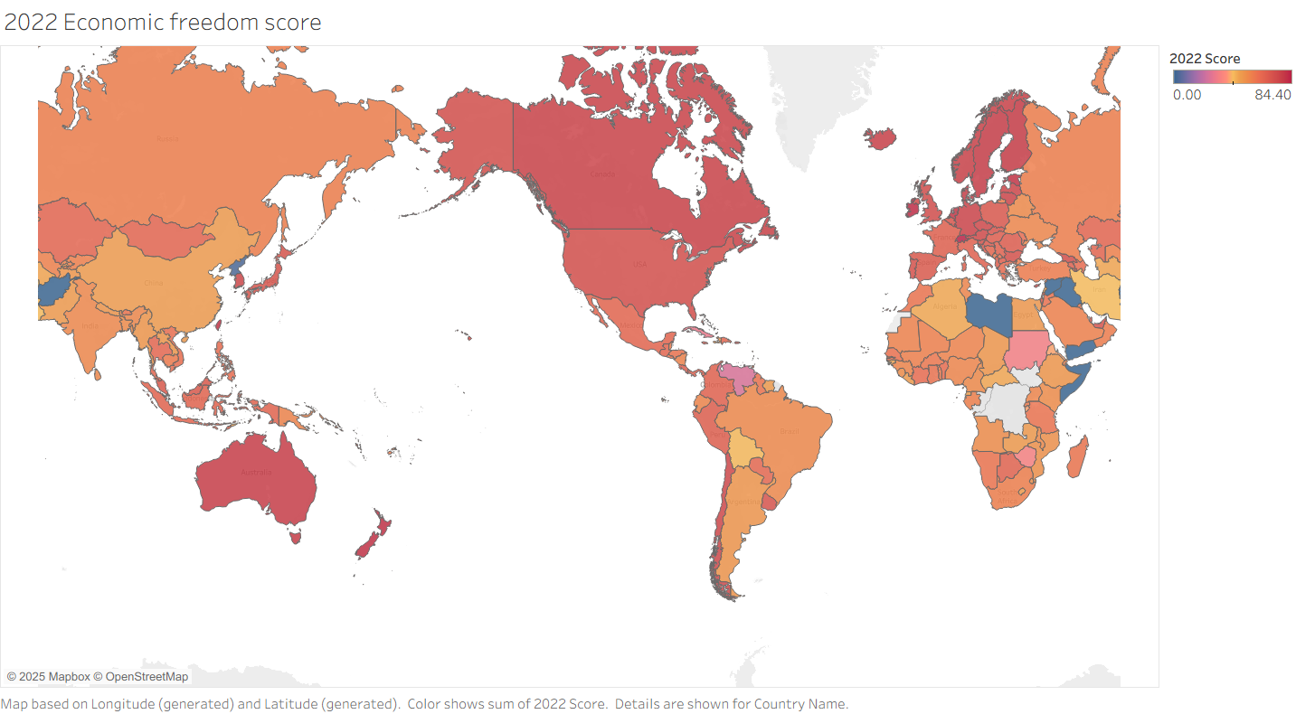

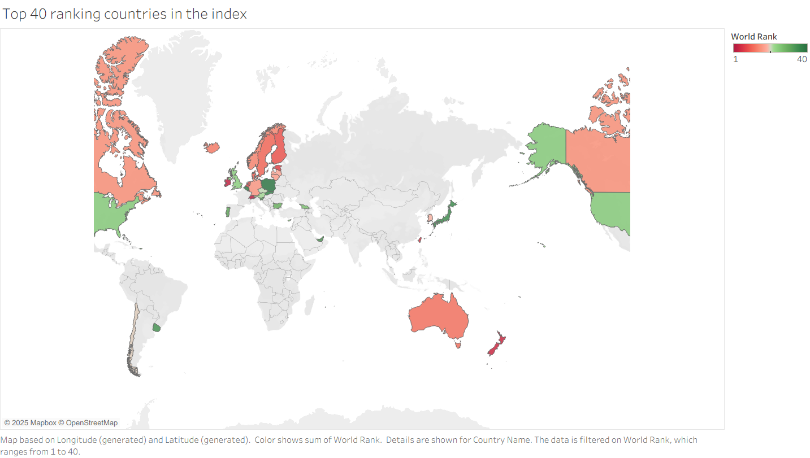

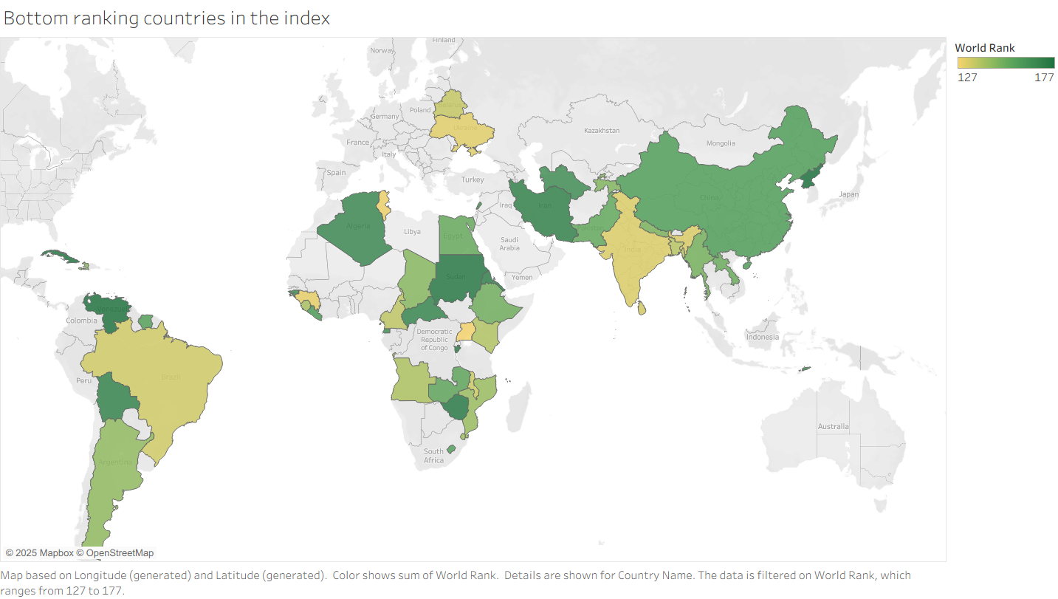

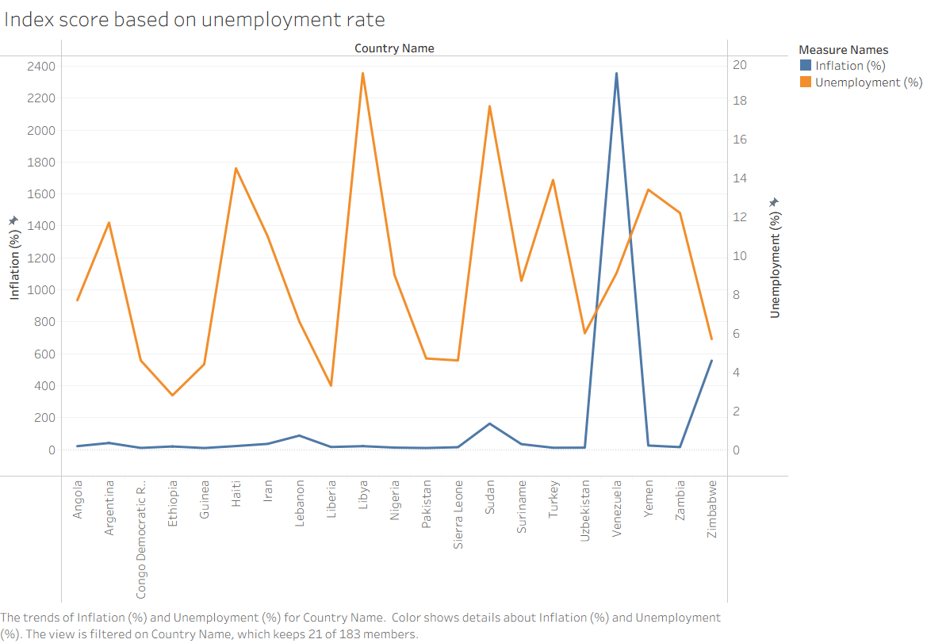

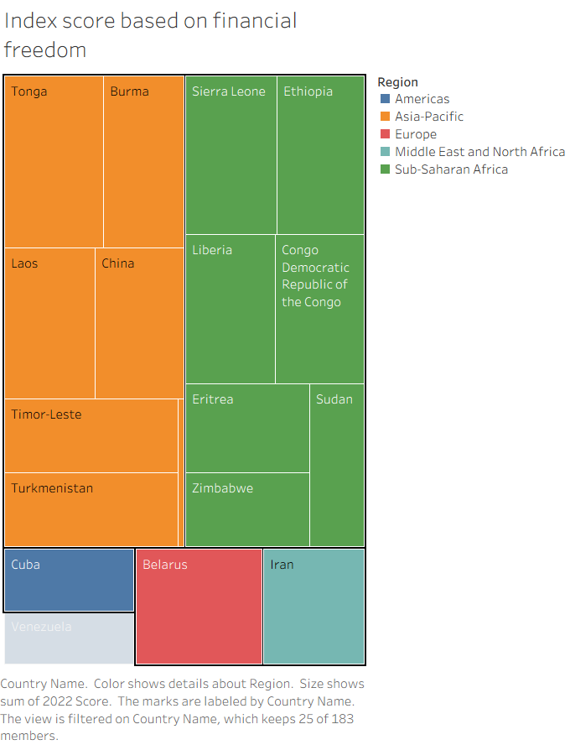

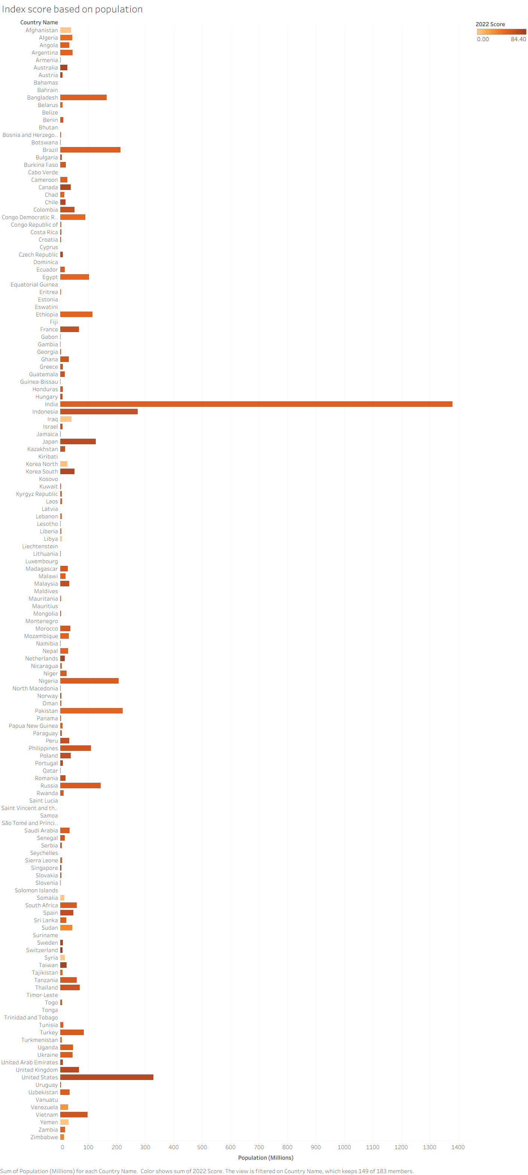

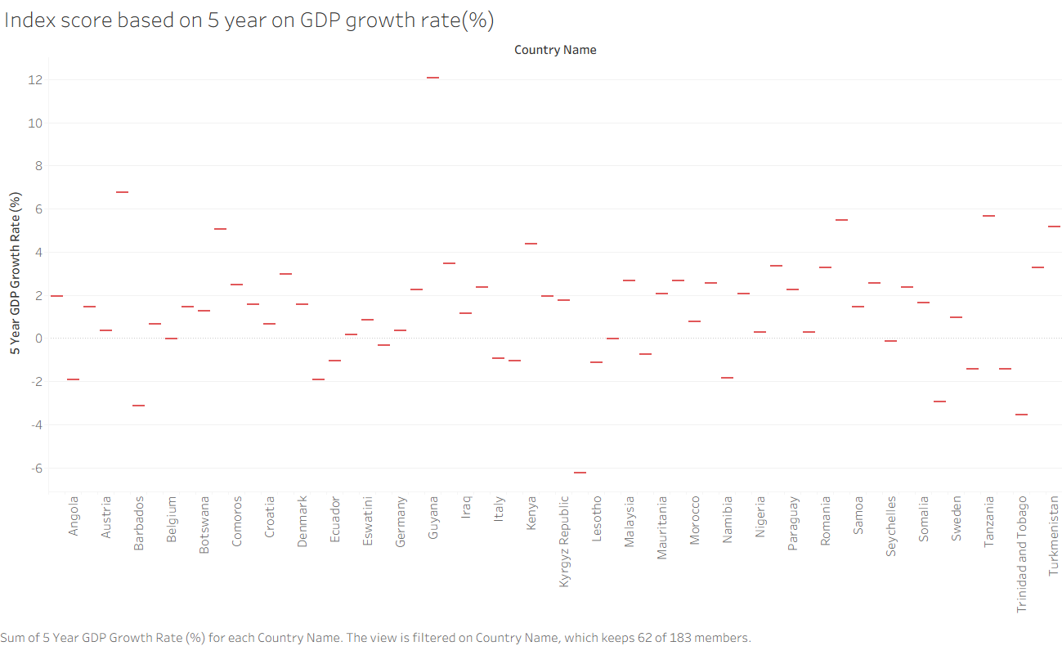

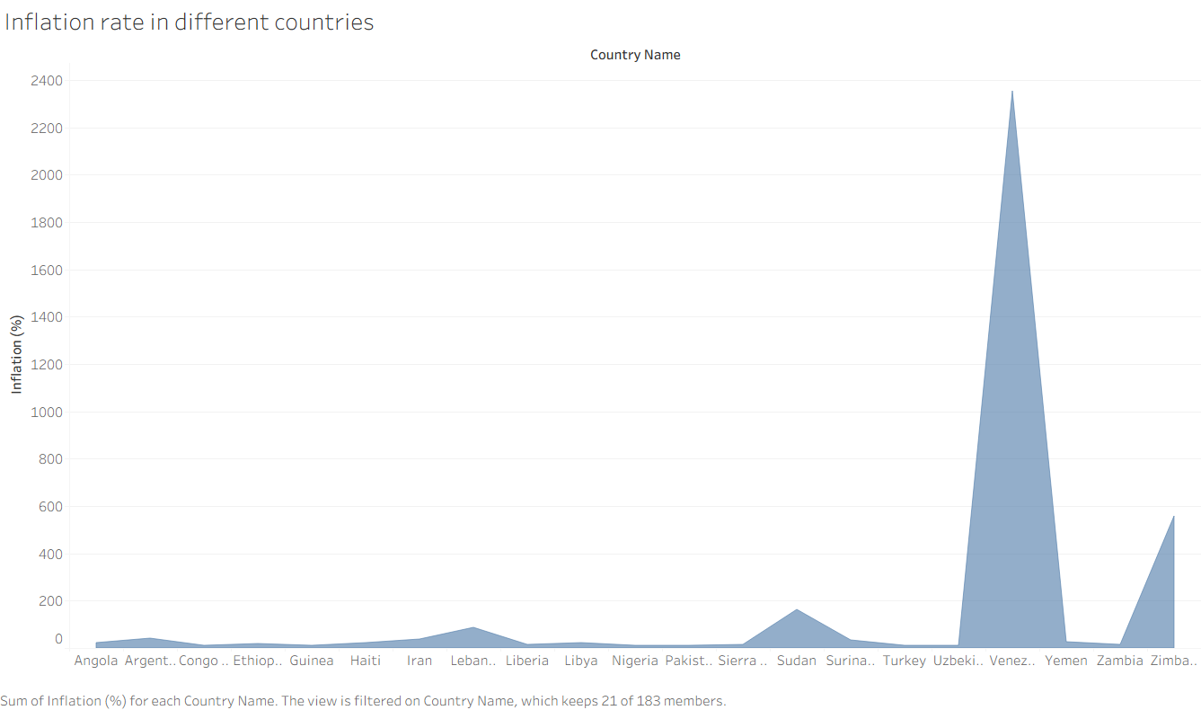

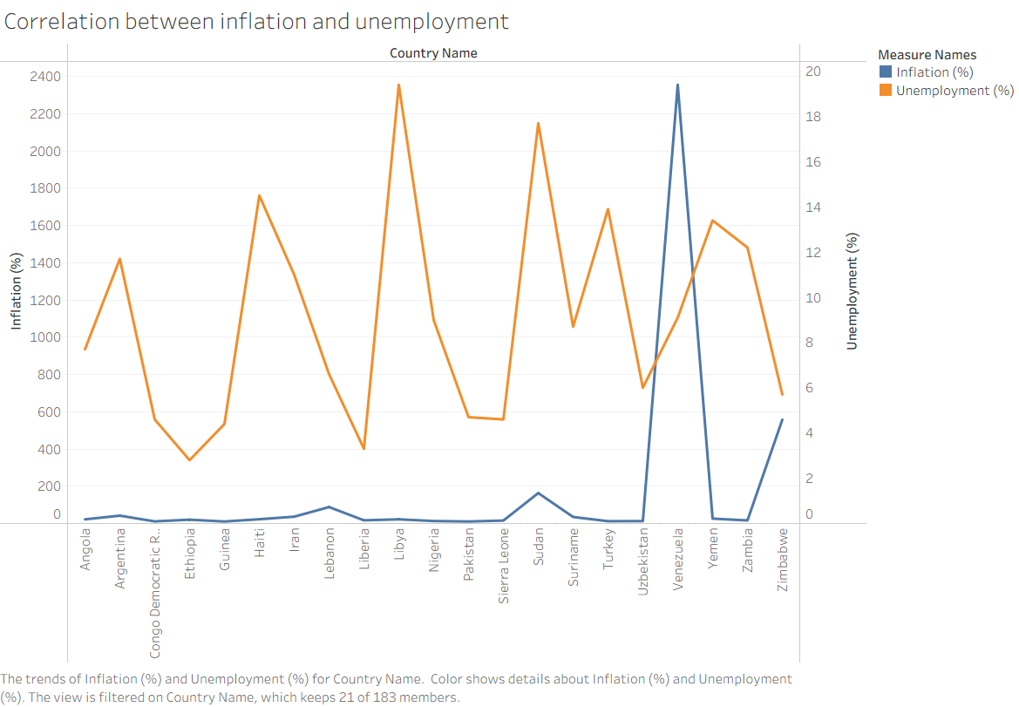

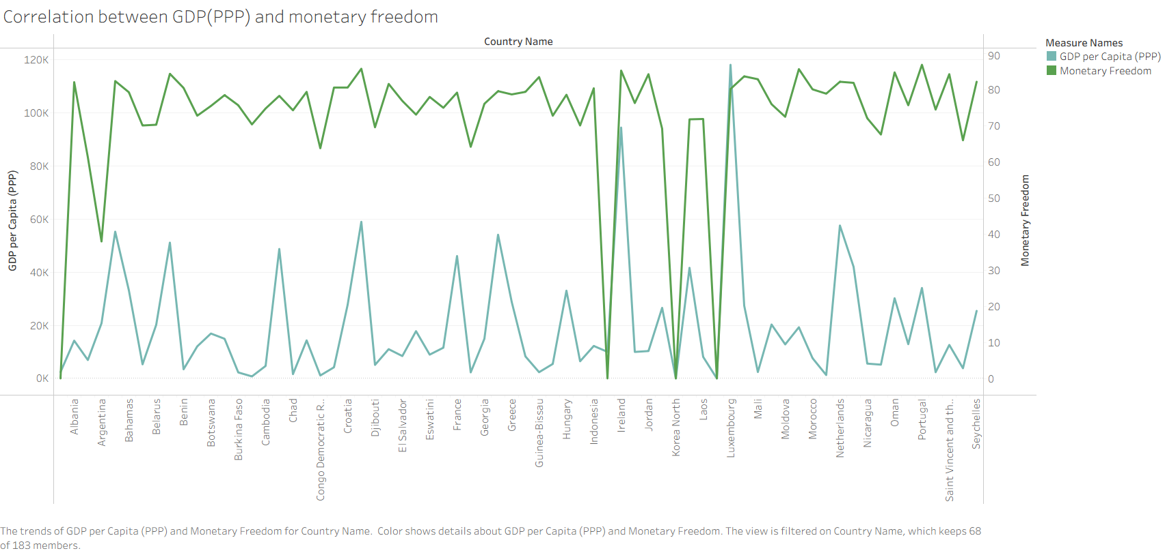

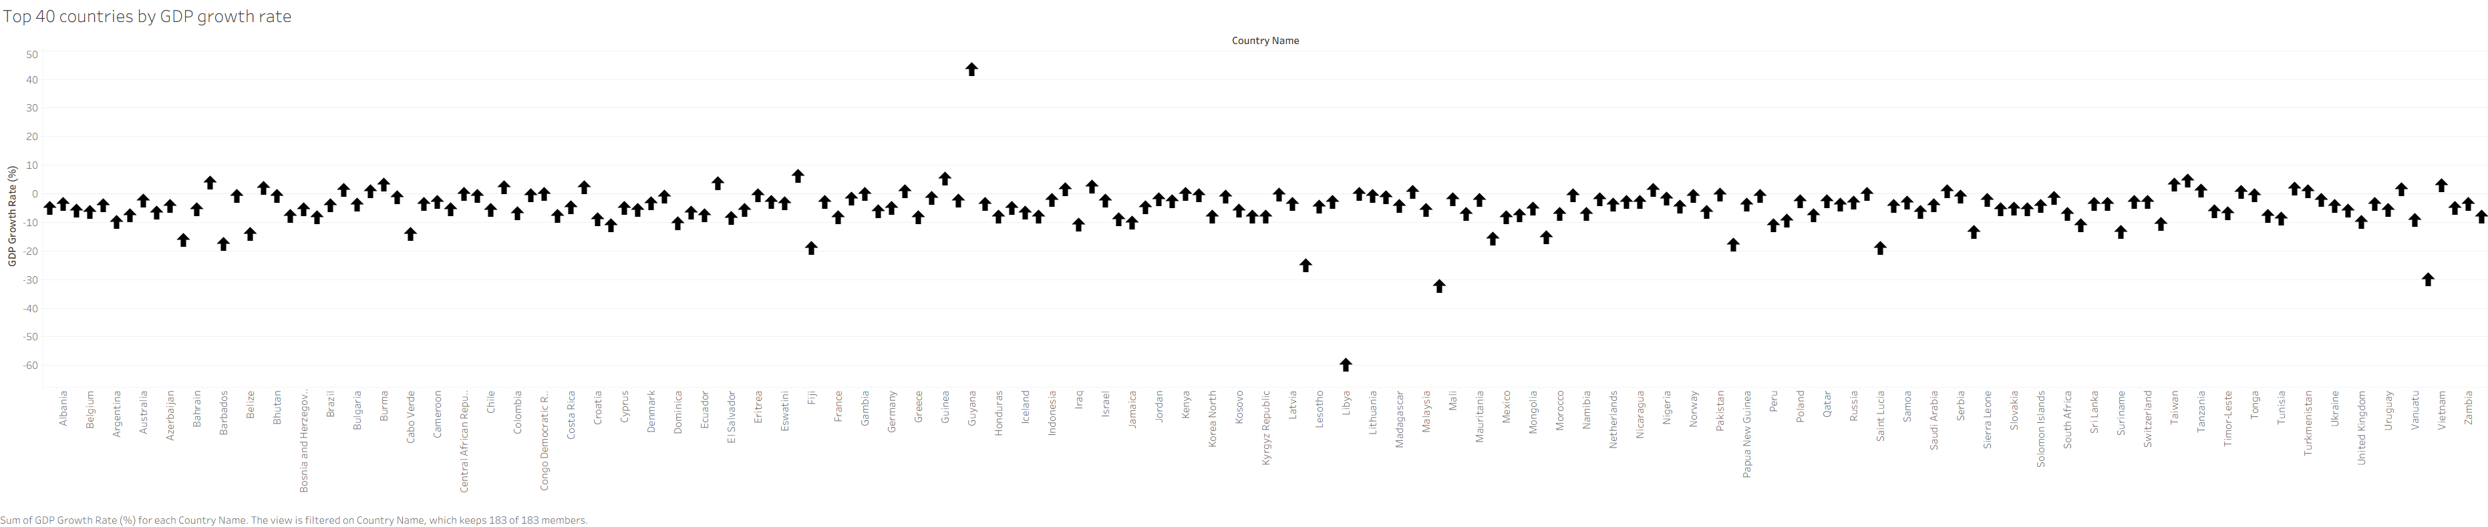

## • ADVANTAGES G DISADVANTAGES

**Advantages:**

* Interactive and user-friendly data exploration
* Visual insights into global economic trends - Supports policymakers, researchers, and students

**Disadvantages:**

* Dependence on third-party data sources
* Some indicators may have subjective interpretations

## 6. CONCLUSION

The project effectively demonstrates how economic freedom correlates with prosperity. By providing visual insights and comparative analysis, it contributes to a better understanding of global economic patterns.

## 10. FUTURE SCOPE

* Inclusion of time-series data for trend analysis

* Expansion of economic indicators such as HDI

* Integration of predictive models for forecasting

## 11. APPENDIX

* **Dataset Link: "C:\Users\bhanu\Downloads\index_of_economic_freedom (1).csv"**

* **Dashboard public link:** [**https://public.tableau.com/app/profile/enugu.bhanu/viz/new_dashboard_17515987140100/Dashboard1?publish=yes**](https://public.tableau.com/app/profile/enugu.bhanu/viz/new_dashboard_17515987140100/Dashboard1?publish=yes)

* **Story board public link:** <https://public.tableau.com/app/profile/enugu.bhanu/viz/new_dashboard_17515987140100/Story1?publish=yes>